**R Code for Examples in the book**

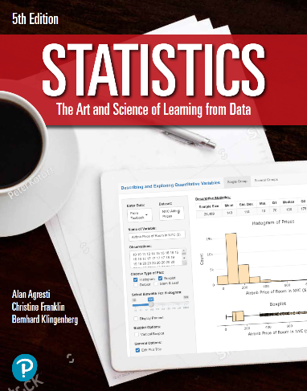

***“Statistics: The Art and Science of Learning from Data”***

**by Agresti, Franklin and Klingenberg, 5th edition**

**Chapter 2**

**Example 10: Cereal Sodium Data – Mean and Median**

## Read in sodium values:

sodium <- c(0, 340, 70, 140, 200, 180, 210, 150, 100, 130, 140, 180, 190, 160,290, 50, 220, 180, 200, 210)

## To find the Mean:

mean(sodium)

## [1] 167

## To find the Median:

median(sodium)

## [1] 180